Everyone who is having a issue with jupyter notebook

Who are not able to open the same then?

**C:\Users\Sonam Soni\AppData\Local\Programs\Python\Python311\Scripts,** in your case the username is different in this given path.

Open Settings

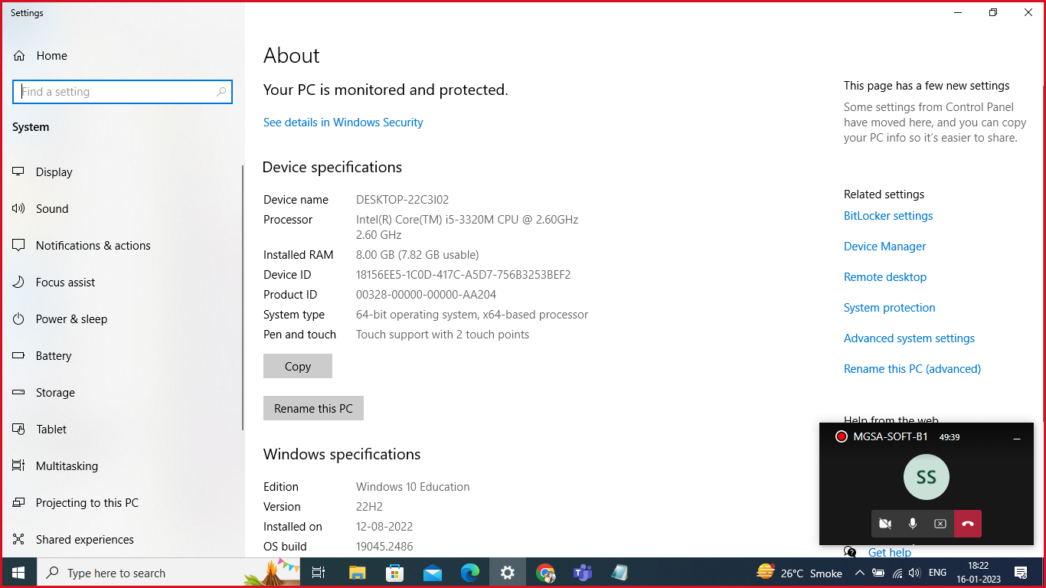

Click on advanced system settings.

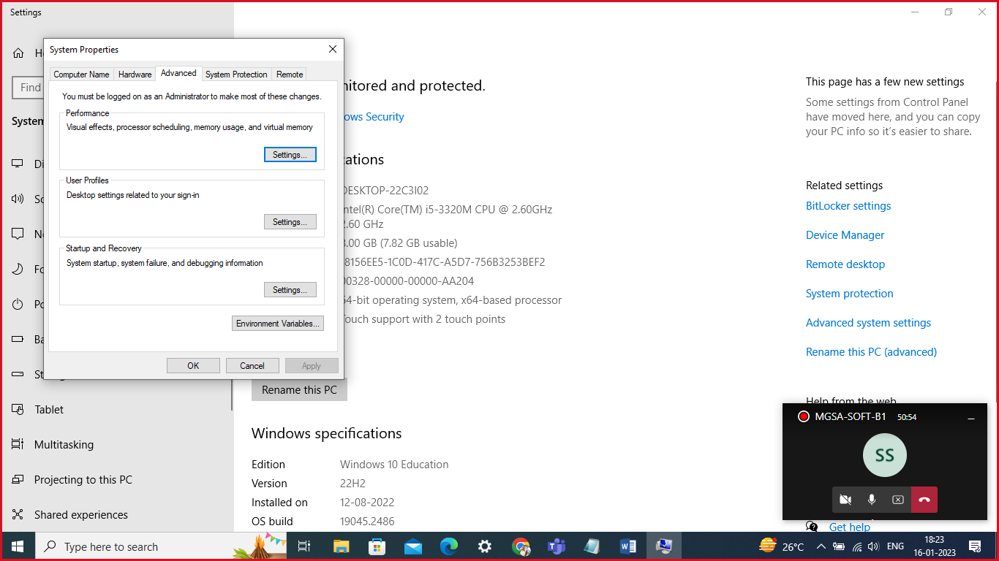

Click on Environment Variable

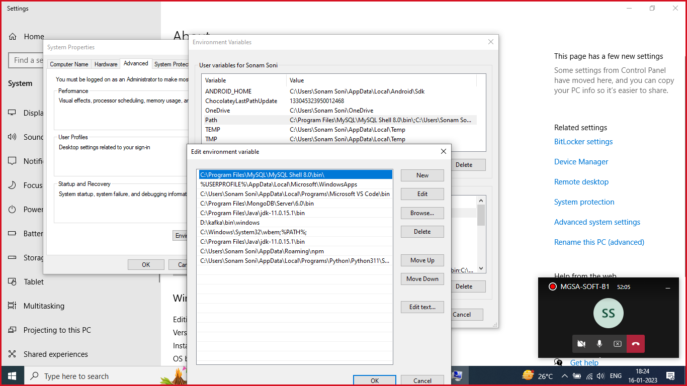

Double click on path. Click on new and add the path which you have copied.

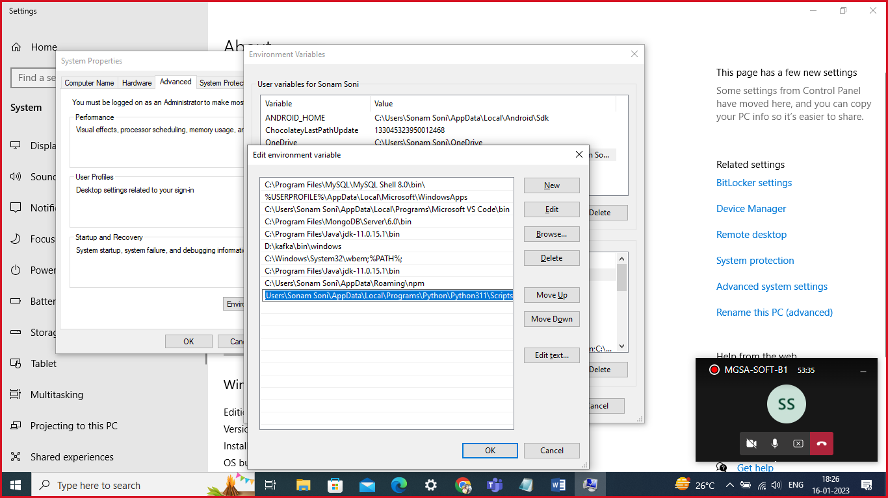

Click on OK, OK and again OK and then check.